Python Refresher - 1
1. Static vs Dynamic Typed Languages
2. Variables vs Objects
3. Register vs Memory
4. Mutability vs Immutability
5. First Class Citizens
6. Python, Memory and Objects
7. Compiler vs Interpreter
8. Basic Python Constructs
9. Python Control Flow
10. Python Functions

Python Refresher - 2

- List Slicing Personal Notes
- Internals of List and Tuples (HW)
- Python Data Structures
- Python Data Structures - 2
- Mutability and Immutability
- Concatenate Lists in Python
- Nested Lists in Python

Python Refresher - 3

- Iteration Protocol
- Python3 Docs
- Tuples
- Truth Value Testing
- List Common Operations
- A tic tac toe that wins in the first attempt
- The dir() function
- Tuple packing and unpacking
- Why is tuple faster than list in Python? - Stack Overflow

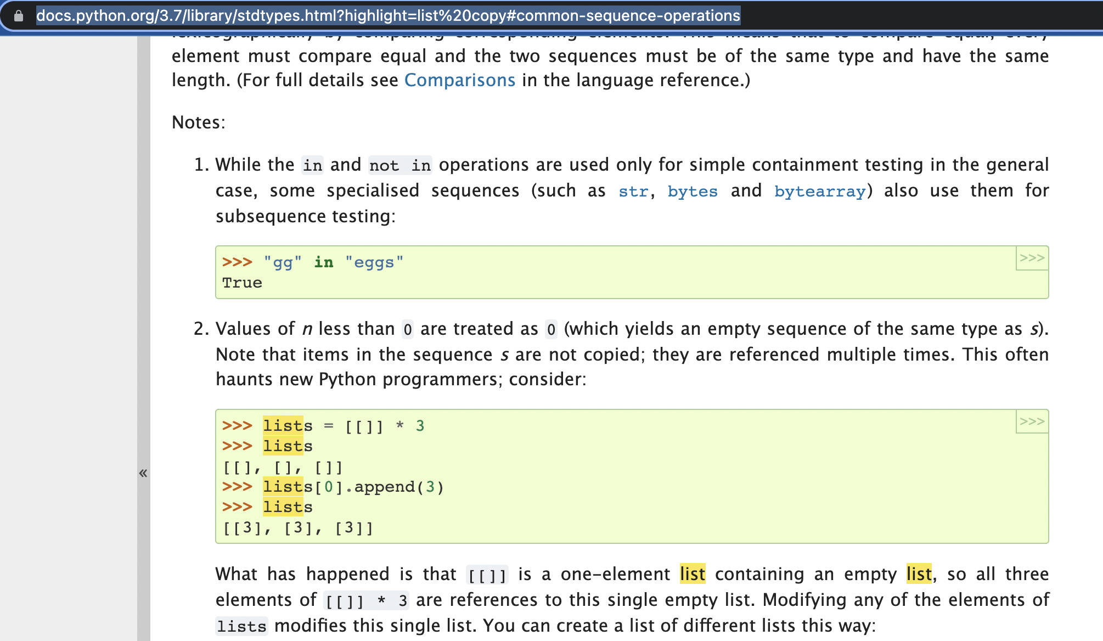

Python Refresher - 4

- How to Approach a Problem
- Comprehensions - List, Set, Dictionary
- Nested Comprehension
- Dictionaries
- Sets
- Set Operations
- Nearest 5 Points
- Revision Strategy
  - Bookmarking
  - Spaced Repetition

